# Stress detection from social media articles

In this part we take a reddit thread dataset- [data](https://www.kaggle.com/datasets/mexwell/stress-detection-from-social-media-articles)  and perform human stress detection. The dataset is created using various articles from reddit threads and each article is annotated with a label of ‘0’ or ‘1’ , where '0' signifies a Stress Negative article and '1' signifies a Stress Positive article. There are more than 3000 articles in the dataset divided into title, body and a combination of title and body.

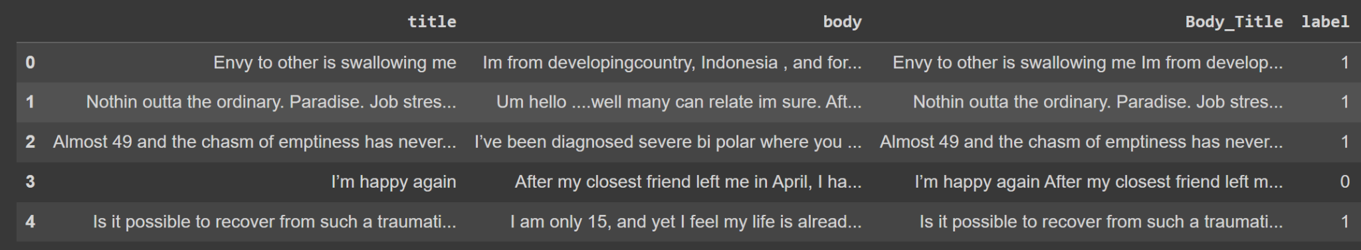

This task can be viewed as a simple text classification task where we make use of the keras nlp library to easily complete this task. KerasNLP is a very easy to use and convenient library which has a lot of pretrained models which can be used as plug-and-play models as per our requirement. So for this particular task we will make use of the Roberta Classifier pipeline which we will just load and train it using our reddit thread dataset to make our predictions.



Text: Envy to other is swallowing me Im from developingcountry, Indonesia , and for now i temporary work overseas for 3 years contract, it's a hard labor job, and stressful…………..

Prediction: 1

## CODE:

## Installation

Pip install pandas keras-nlp numpy

## Imports

Import pandas as pd

import keras_nlp

Import numpy as np

## Data Loading

df = pd.read_csv('Reddit_Combi.csv',sep=';')

df.head()

## Data processing

text = df.Body_Title

labels = df.label

## Model Building and training

classifier = keras_nlp.models.RobertaClassifier.from_preset(

"roberta_base_en",

num_classes=2,

)

classifier.fit(x=text.values, y=labels, batch_size=8, verbose=1)

## Making predictions

pred = classifier.predict([text.values[0]])

print(text.values[0])

np.argmax(pred[0],0)